LAB 6 RESULTS

1)Login Screen

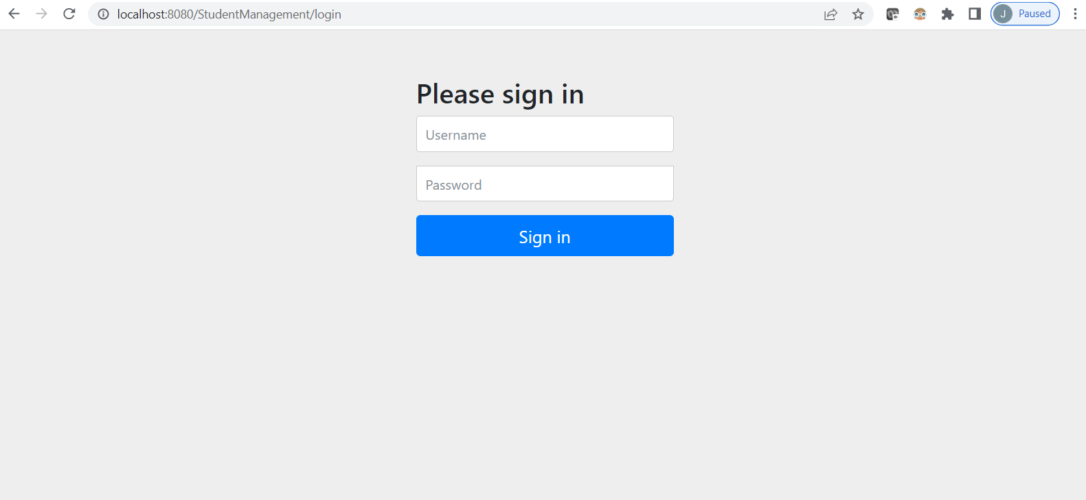

2)Login using user madhu having ADMIN role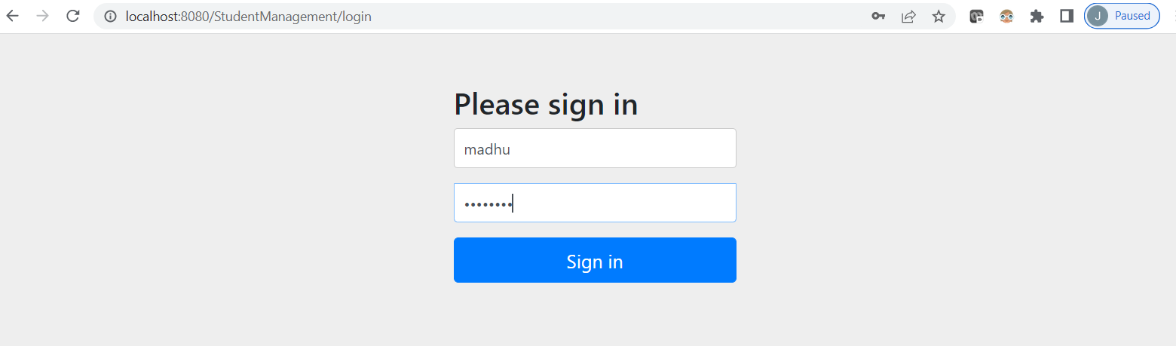

3)Student list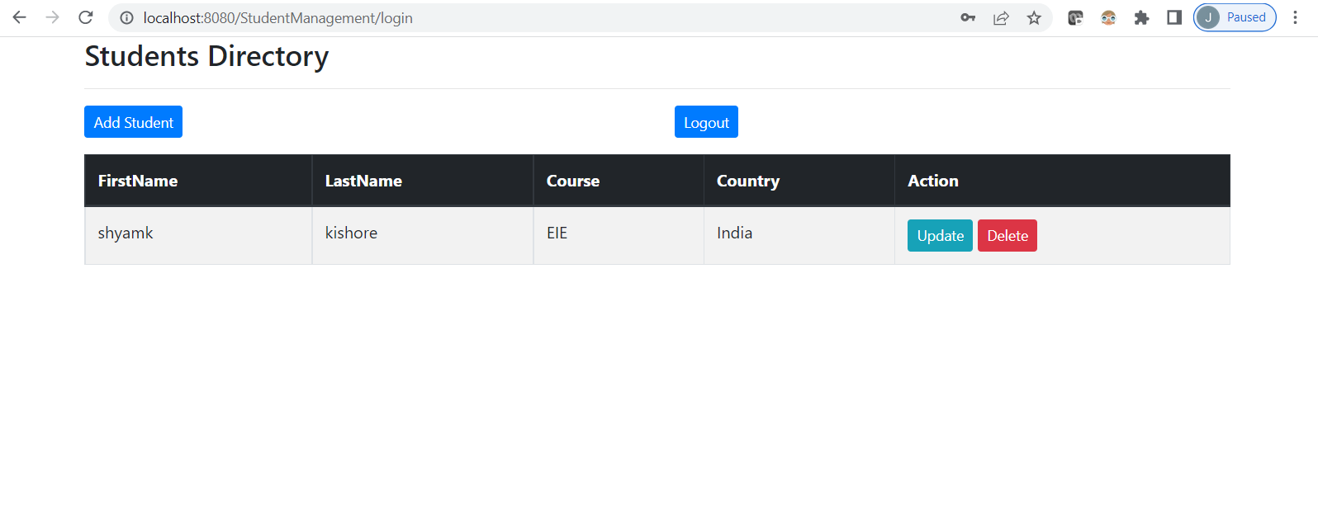

4) Updating the first name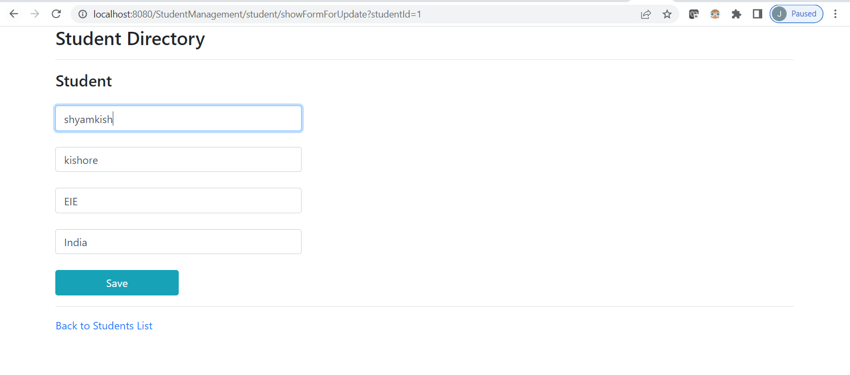

5)Updated name reflecting In list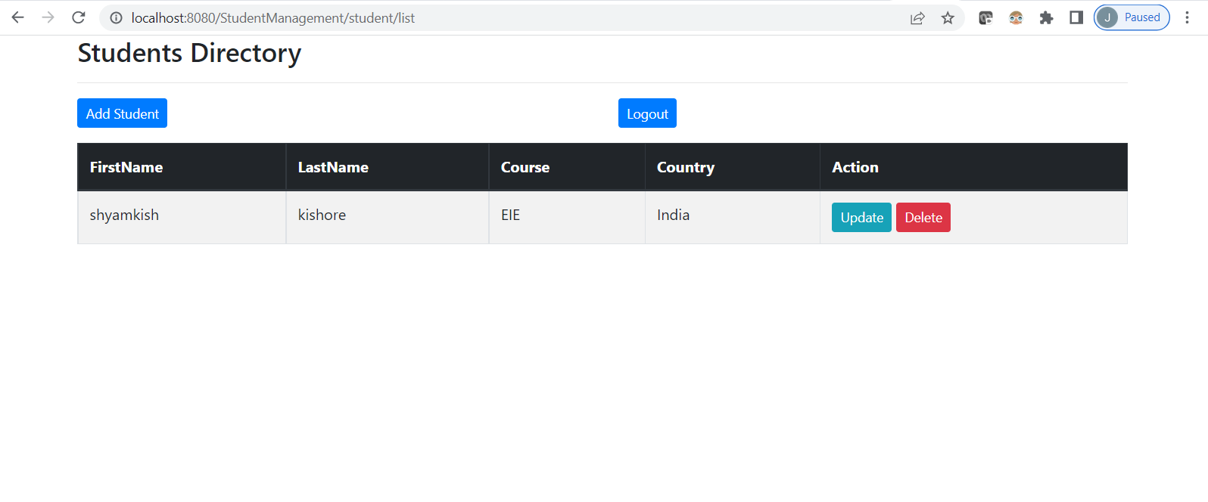

6)Adding new student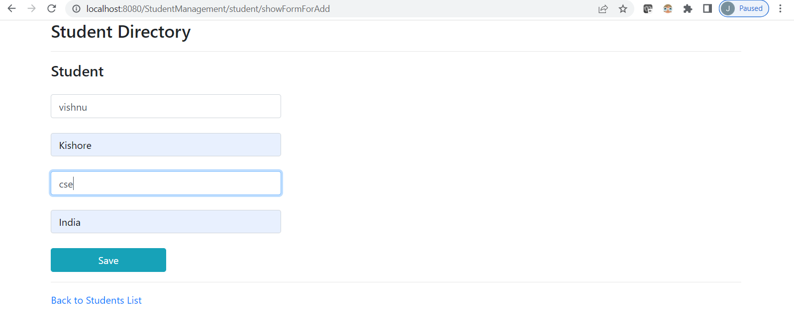

7)New Student Added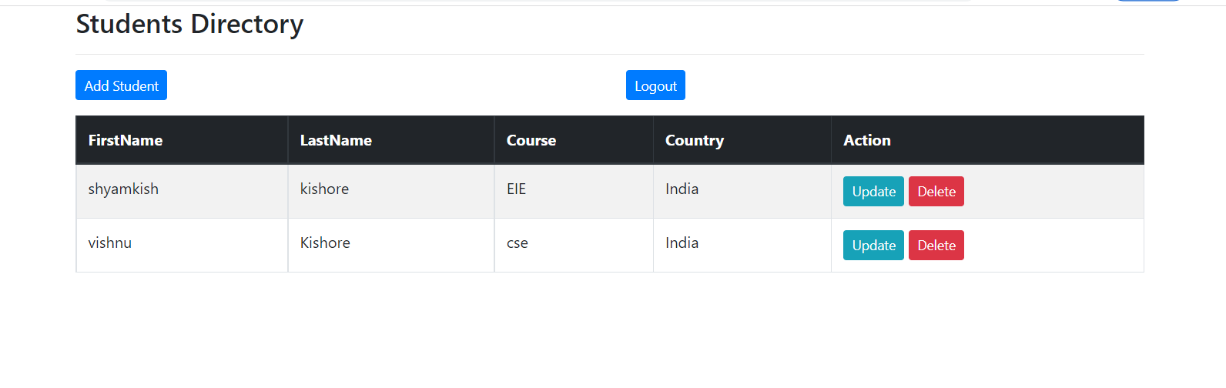

8)Admin Deleting student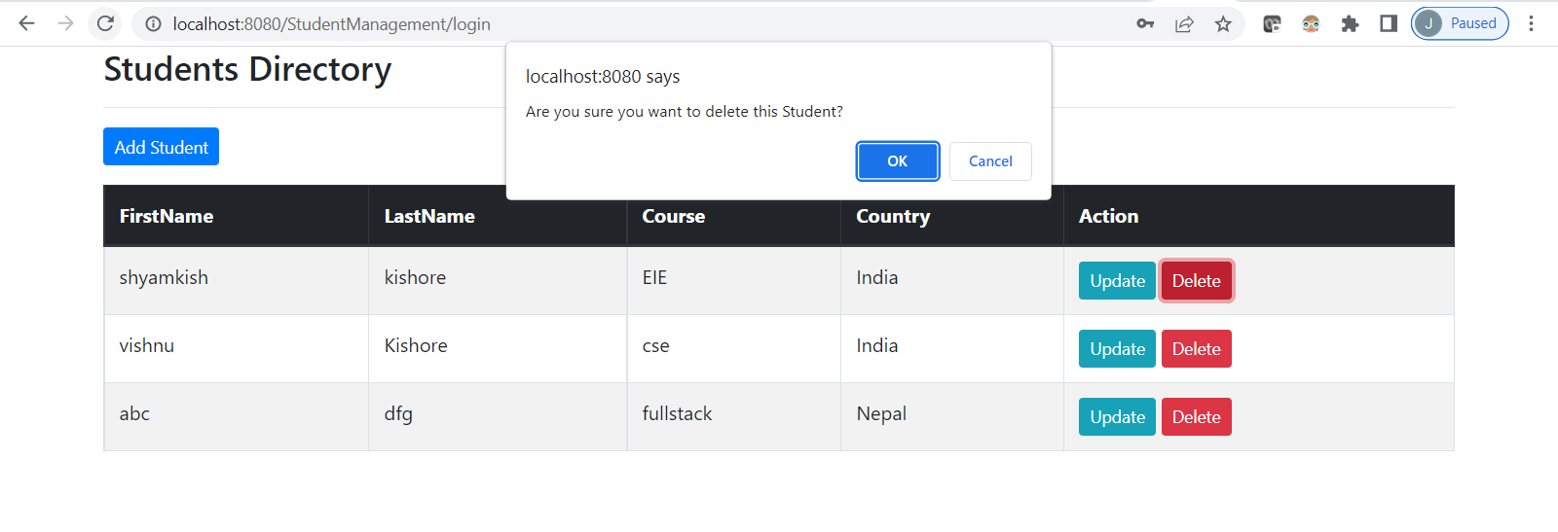

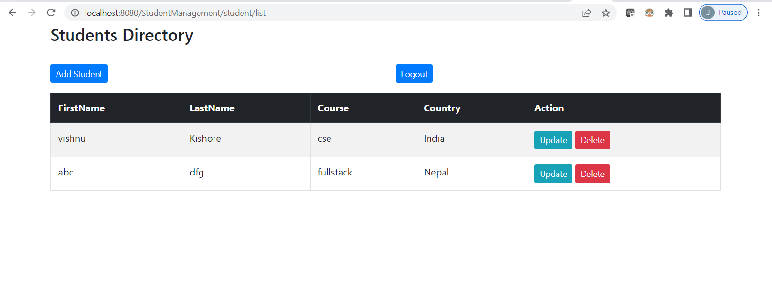

9)Sign in using user1 having USER role

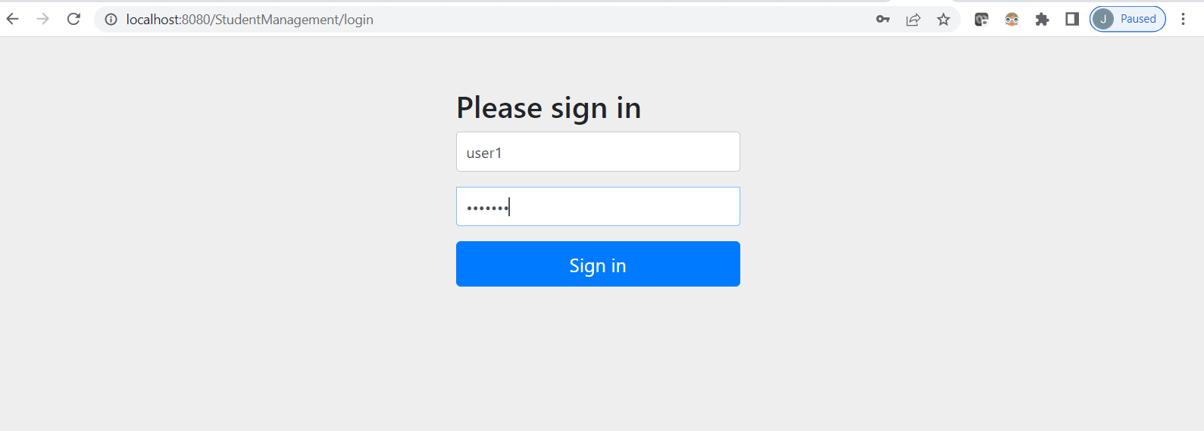

10)Student list can be accessed by user1 having user role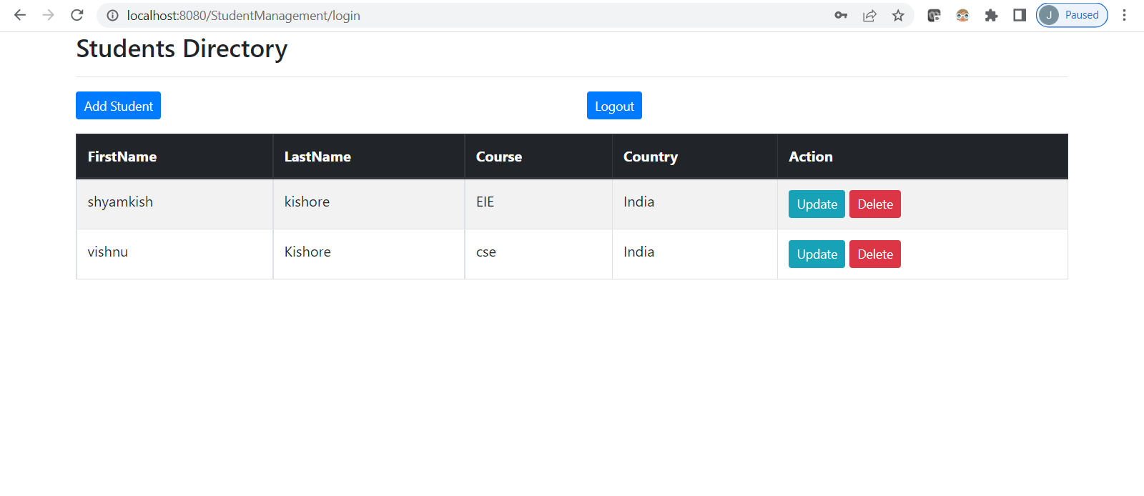

11)Student can also be added by the user1 with user role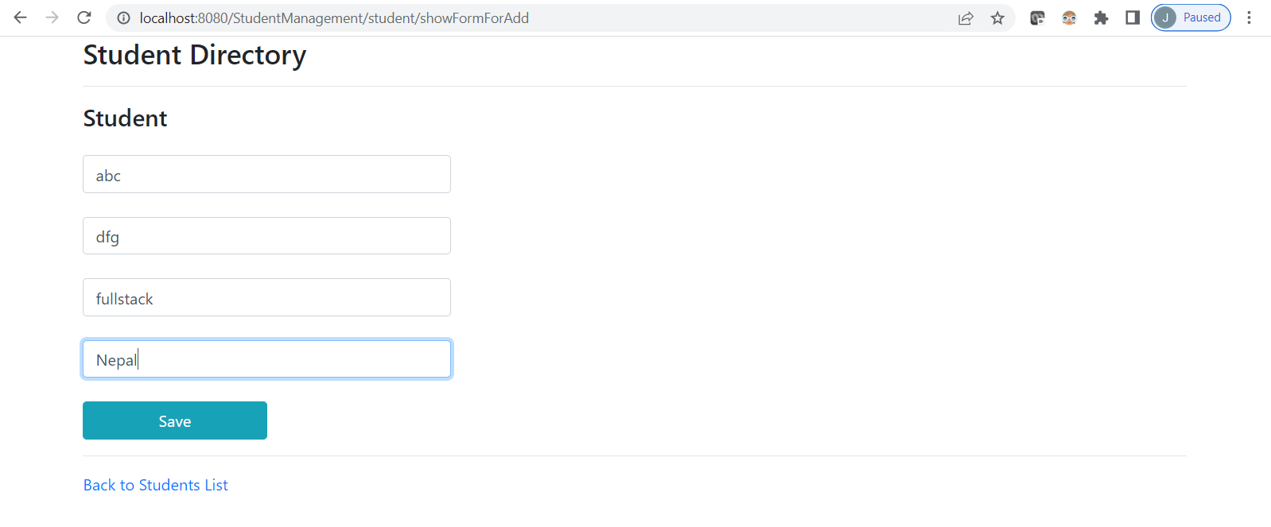

12)Student cannot be updated by user role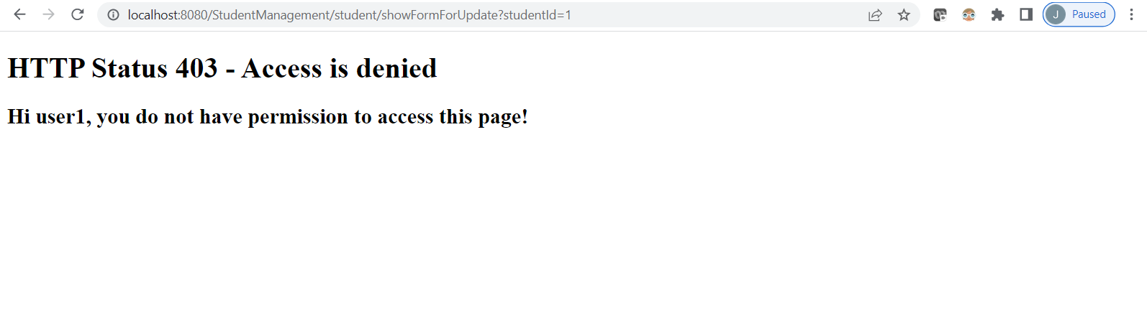

13)User role cannot delete the student also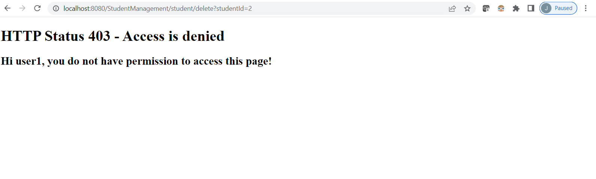

14)tabe users,roles,users_roles and student created spring DB in MySQL

